**L’Epée 1839 Creative Art Residency**

**Presenting Unique creations highlighting the manufacture’s métiers and inspired artistic partnerships**

L’Epée 1839 draws inspiration from worlds as diverse as contemporary design, and various art forms. Today our manufacture unveils a new series of unique creations, highlighting its craftsmanship and daring creativity. Iconic pieces from its Creative Art line are reimagined through an artistic lens, each transformed into a one-of-a-kind work of art. Every Unique piece showcases either the manufacture’s full in-house expertise or its collaborations with talented artists. The result is a collection of kinetic sculptures that transcend artistic boundaries, blending craft and creativity into singular masterpieces — each with its own distinct personality, and feel, celebrating artistry and individuality.

Behind every creation is a team of designers, engineers, mechanics, and master watchmakers whose passion drive the manufacture forward. From development to the final assembly, each clock passes through the hands of these artisans, who combine centuries-old know-how with bold innovation. Their expertise ensures that every detail — from the beating heart of the movement to the gleaming surface finish — reflects the soul of true craftsmanship.

The manufacture has been a place of creative partnerships, embracing collaborations and exploring new territories, where in-house expertise and external artistry come together to enrich each creative piece. Driven by this spirit of co-creation and innovation, L’Epée 1839 continues to push the boundaries of horology, offering collectors pieces that are timeless, daring, and fused with artistic expression.

Renowned for its technical mastery, extra-long power reserves, impeccable finishing, playfulness and unexpected touches of humor, L’Epée 1839 has earned a reputation for turning clocks into extraordinary kinetic mechanical sculptures.

For more than 185 years, L’Epée 1839 has cultivated the art of high-end mechanical clockmaking. Today, it remains the only Swiss manufacture fully dedicated to mechanical clocks, preserving traditional savoir-faire while embracing innovation under one roof.

**L’Epée 1839 Time Fast Collection x The Dial Artist**

***Resident artist : Chris Alexander (Aka The Dial Artist)***

***Georg Foster + L’ECAL, designer***

Following our very first collaboration on the Grenade timepiece, celebrating street Art, Art Bombing and Graffiti, L’Epée 1839 and Chris Alexander (aka The Dial Artist), join forces again on a collection of special hand-painted car-inspired Timepieces.

This collaboration consists of a series of one-of-a-kind creations, uniting the design and in-house movement of L’Epée 1839’s Time Fast collection with the expressive paintwork of The Dial Artist. Guided by his strokes and colors, each kinetic sculpture emerges with its own distinct character — a celebration of individuality and authenticity.

Time Fast D8 Raced, Time Fast II « Urban Racer » and Time Fast D8 by TDA take the opportunity to visualize the artistic meaning of the ‘Art-Bomb’ – a form of art that challenges the norm and public perception. Additionally, the graffiti culture refers to ‘bombing’ as a process of painting walls or objects with tags and throw-ups.

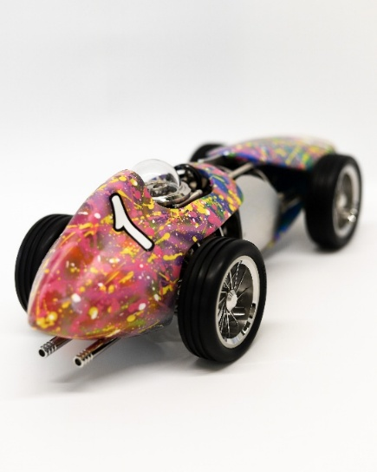 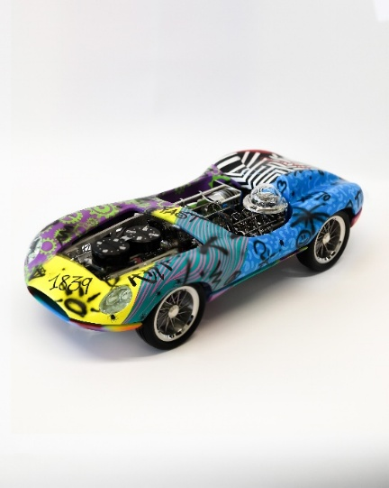 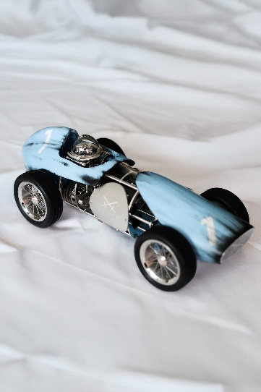

**The Time Fast collection**

Inspired by the golden age of racing, the Time Fast collection reimagines the legendary Formula 1 cars of the 1930s to 1960s as kinetic works of art, blending authentic design with horological mastery. Built on an aluminum H-chassis like the racing cars of the era, each model integrates an in-house movement designed to follow the aerodynamic curves of the bodywork. Authentic details abound: a three-spoke steering wheel to set the time, finely crafted spoked stainless-steel wheels, the escapement placed beneath the driver’s helmet, and soft rubber tires filled with foam to replicate the feel of real racers. The Time Fast cars come alive when the rear wheels are pushed back, echoing the nostalgic joy of childhood pull-back toy cars.

The Time Fast D8, the very first model of the collection, quickly became a best seller and an icon of the brand. Admired for its sleek, timeless lines and understated elegance, it embodies the spirit of vintage racing in a pure, sculptural form — with the time displayed like a racing number.

Building on this success, Time Fast II pushes the concept further with greater technical depth and playful mechanics. Equipped with two independent movements — one for timekeeping and another for a miniature V8 engine animation — it offers an even more immersive experience. A functional gear stick lets the owner switch between modes, while turning the dashboard key sets the pistons in motion in a captivating mechanical display.

**Time Fast D8 Raced – “Race weathered”**

The inspiration struck during a holiday—often the perfect moment to reflect and reimagine. In a casual yet creatively charged phone call with the L’Epée 1839 team, the idea took shape, rooted in shared memories of miniature modelling and painting. Chris, with his background in luxury miniature car modeling, had developed a unique set of techniques and processes over the years. As the conversation turned to the beauty of time’s impact on objects, the concept emerged naturally: to craft a 'raced' patina effect on one of our iconic racecar timepieces.

“Doing a Raced patina effect would look epic! - Imagine a Time Fast that looks like it’s lived a thousand laps—weathered by speed, marked by history,” Chris proposed. The vision was clear: to reinterpret the Time Fast D8 with the visual poetry of a machine shaped by performance and endurance, offering a bold, new perspective on a contemporary classic.

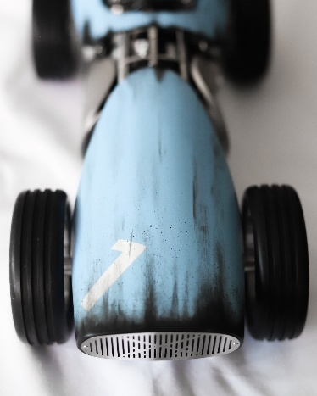

**Time Fast D8 by The Dial Artist – “Graffiti Art Bombing”**

**Time Fast II by the Dial Artist – “Urban Racer”**

Chris Alexander and L’Epée 1839 delve into the fusion of street art and automotive customization, transforming vehicles into moving canvases through the bold language of graffiti—once confined to walls, trains, and urban landscapes. This striking form of expression speaks to both artistry and rebellion, echoing themes of identity, freedom, and cultural narrative.

Here the Dial Artist used our two iconic racecar models, Time Fast D8 and Time Fast II into a new platform of expression.

Just like Ken Block's drift cars often having wild custom paint jobs influenced by graffiti, Art cars at Burning Man— Graffiti Art cars sit at the crossroads of cultures and art movements.

L’Epée 1839 and Chris Alexander sought to authentically engage with the essence of street culture—a powerful intersection of fashion, music, dance, language, and lifestyle, deeply embedded in creativity, self-expression, and cultural identity.

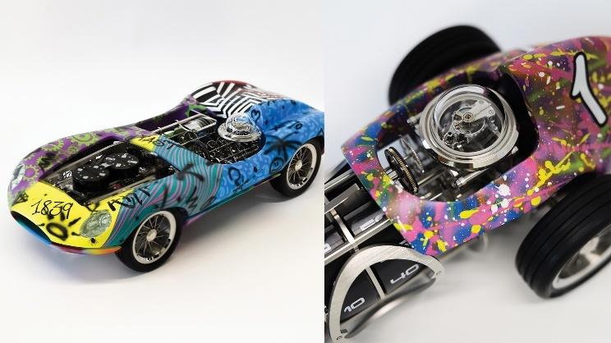

**About artist Chris Alexander**

Chris Alexander, known as The Dial Artist, is a British artist based in Scotland. Drawing inspiration from his childhood in South Africa, as well as Street Art, Pop Culture, Astrology, and Abstract Expressionism, he uses his platform to merge creativity with his love for horology.

A graduate of Gray’s School of Art with a Master’s in Design, Chris founded The Dial Artist in 2017 after more than 20 years in the creative industries. Through years of experimentation with paints, lacquers, and techniques, he developed his distinctive style — abstract dials bursting with color that blur the lines between contemporary art and horology.

Today, his works are celebrated worldwide, transforming each dial into a moving canvas. Chris sees every piece as a **collaboration between client, artist, and watch**, resulting in unique creations that reflect both personal passions and his unmistakable artistic identity.

**Georg Foster, designer + ECAL**

Son of an engineer, Georg Foster (26) discovered a passion for mechanics at a young age. After studying design in London (London College of Communication and Central Saint Martins), Georg continued his professional development in the fields of furniture, jewelry and accessories, working in particular on artisanally produced motorbike helmets. This varied experience brought him closer to the world of luxury, know-how and high-precision work. In 2017, he enrolled in a Master of Advanced Studies in Design for Luxury and Craftsmanship at ECAL (Ecole cantonale d’art de Lausanne). Established 10 years ago, this program brought him into direct contact with industry professionals, enabling him to work with prestigious brands in the fields of tableware, fashion, gastronomy, cosmetics and fine watchmaking.

During Georg studies, thanks to a partnership between ECAL and L’Epée 1839, Arnaud and Georg got to know each other and design the First Time Fast. Arnaud already had in mind the design of a second cars, a 2 seated one and when time has come to start the development, he naturally came to George to ask him to work with him on the project.

**Technical Specifications :**

Dimensions

Time Fast D8 : 385 x 160 x 120 mm   
Time Fast II : 450 × 189 × 120 mm

Functions

* Hour and minute displays on rotating disks
* Time set via steering wheel: counterclockwise to set, clockwise to reposition
* Wound via rear wheels: reversing the car winds the mainspring barrels
* (Time Fast II) Gearbox lever selects which barrel is wound
* (Time Fast II) Moves freely forward and backward in neutral
* (Time Fast II) Dashboard key starts engine piston automat

Movement : L’Epée 1839 in-house movement, 8 day

Bodywork & Wheels : Aluminum bodywork (top and bottom), Blown glass dome, polished to simulate driver’s helmet, 12-spoke stainless-steel rims, Soft compound rubber tires with foam insert for authentic deformation

Materials & Finishing: Palladium-plated brass, stainless steel, anodized aluminum - Finishes: polished, satin-finished, sand-blasted movement / polished & satin-finished rims / lacquered bodywork