**L’Epée 1839 Creative Art Residency**

**Presenting Unique creations highlighting the manufacture’s métiers and inspired artistic partnerships**

L’Epée 1839 draws inspiration from worlds as diverse as contemporary design, and various art forms. Today our manufacture unveils a new series of unique creations, highlighting its craftsmanship and daring creativity. Iconic pieces from its Creative Art line are reimagined through an artistic lens, each transformed into a one-of-a-kind work of art. Every Unique piece showcases either the manufacture’s full in-house expertise or its collaborations with talented artists. The result is a collection of kinetic sculptures that transcend artistic boundaries, blending craft and creativity into singular masterpieces — each with its own distinct personality, and feel, celebrating artistry and individuality.

Behind every creation is a team of designers, engineers, mechanics, and master watchmakers whose passion drive the manufacture forward. From development to the final assembly, each clock passes through the hands of these artisans, who combine centuries-old know-how with bold innovation. Their expertise ensures that every detail — from the beating heart of the movement to the gleaming surface finish — reflects the soul of true craftsmanship.

The manufacture has been a place of creative partnerships, embracing collaborations and exploring new territories, where in-house expertise and external artistry come together to enrich each creative piece. Driven by this spirit of co-creation and innovation, L’Epée 1839 continues to push the boundaries of horology, offering collectors pieces that are timeless, daring, and fused with artistic expression.

Renowned for its technical mastery, extra-long power reserves, impeccable finishing, playfulness and unexpected touches of humor, L’Epée 1839 has earned a reputation for turning clocks into extraordinary kinetic mechanical sculptures.

For more than 185 years, L’Epée 1839 has cultivated the art of high-end mechanical clockmaking. Today, it remains the only Swiss manufacture fully dedicated to mechanical clocks, preserving traditional savoir-faire while embracing innovation under one roof.

**The Fluorescent editions : Regatta and Time Fast II**

***Resident artist Floriano Castaldi, artist***

***Designers: Milagros Rodriguez (Regatta), Georg Foster (Time Fast II)***

Using a unique painting technique, L’Epée 1839 partnered with skilled automotive painter Floriano Castaldi, to create a striking finish that blends the brilliance of chrome with vibrant colors. The result is a unique surface treatment that reflects both technical mastery and artistic daring, transforming the timepiece into a true work of kinetic art.

**About artist Floriano Castaldi**

Artist Floriano Castaldi unveils his chrome technique, a new pictorial approach exploring metallic reflections and the illusion of material. Working across various mediums, he plays with light, depth, and texture to create works with a striking chrome-like appearance. This series questions our relationship with image, surface, and perception, at the crossroads of contemporary art and technical experimentation.

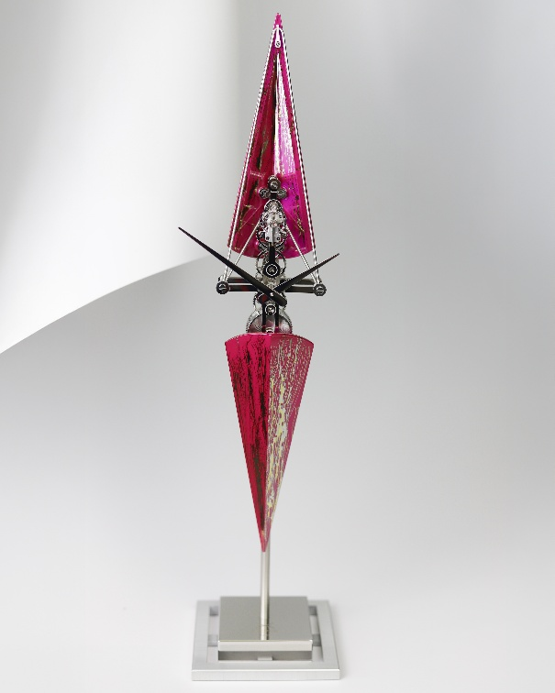 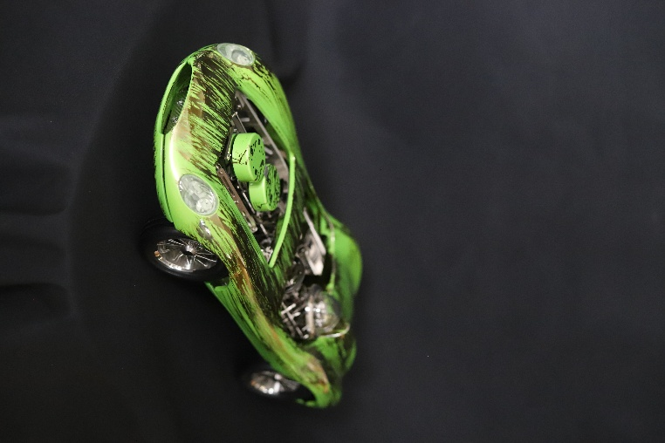

**Technical specifications**

The Fluorescent Regatta

Dimensions & Weight: 518 mm high, base 120 mm square - 1.75 kg

Functions : Hours and minutes

Movement : L’Epée 1839 in-house mechanical movement, 8-day power reserve

Materials & Finishing : Palladium-plated brass, Stainless steel Aluminium, special lacquering technique