**L’Epée 1839 Creative Art Residency**

**Presenting Unique creations highlighting the manufacture’s métiers and inspired artistic partnerships**

L’Epée 1839 draws inspiration from worlds as diverse as contemporary design, and various art forms. Today our manufacture unveils a new series of unique creations, highlighting its craftsmanship and daring creativity. Iconic pieces from its Creative Art line are reimagined through an artistic lens, each transformed into a one-of-a-kind work of art. Every Unique piece showcases either the manufacture’s full in-house expertise or its collaborations with talented artists. The result is a collection of kinetic sculptures that transcend artistic boundaries, blending craft and creativity into singular masterpieces — each with its own distinct personality, and feel, celebrating artistry and individuality.

Behind every creation is a team of designers, engineers, mechanics, and master watchmakers whose passion drive the manufacture forward. From development to the final assembly, each clock passes through the hands of these artisans, who combine centuries-old know-how with bold innovation. Their expertise ensures that every detail — from the beating heart of the movement to the gleaming surface finish — reflects the soul of true craftsmanship.

The manufacture has been a place of creative partnerships, embracing collaborations and exploring new territories, where in-house expertise and external artistry come together to enrich each creative piece. Driven by this spirit of co-creation and innovation, L’Epée 1839 continues to push the boundaries of horology, offering collectors pieces that are timeless, daring, and fused with artistic expression.

Renowned for its technical mastery, extra-long power reserves, impeccable finishing, playfulness and unexpected touches of humor, L’Epée 1839 has earned a reputation for turning clocks into extraordinary kinetic mechanical sculptures.

For more than 185 years, L’Epée 1839 has cultivated the art of high-end mechanical clockmaking. Today, it remains the only Swiss manufacture fully dedicated to mechanical clocks, preserving traditional savoir-faire while embracing innovation under one roof.

**Flying Tourbillon by L’Epée 1839 x Vincent Calabrese**

In a bold celebration of horology’s most revered complication, The tourbillon, L’Epée 1839 unveils two special unique pieces—transcendent masterpieces born from the visionary collaboration with master watchmaker Vincent Calabrese and talented artists.

The Creative piece is presented in two hand-painted housings: *Phoenix Eternis Ignis* by artist Morena Fetoshi and The *Icon – Beaux Arts* by artist Séverine Bugna. These exceptional creations unite technical mastery with artistic expression, embodying the daring spirit of the manufacture.

***Unique piece 1: The Phoenix Eternis Ignis***

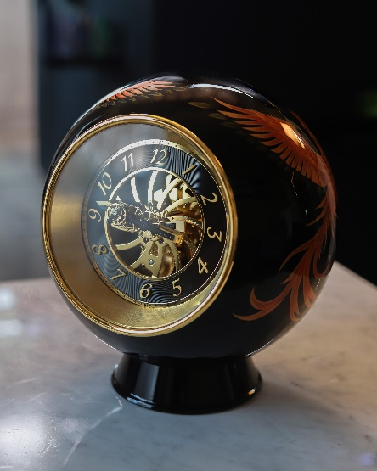 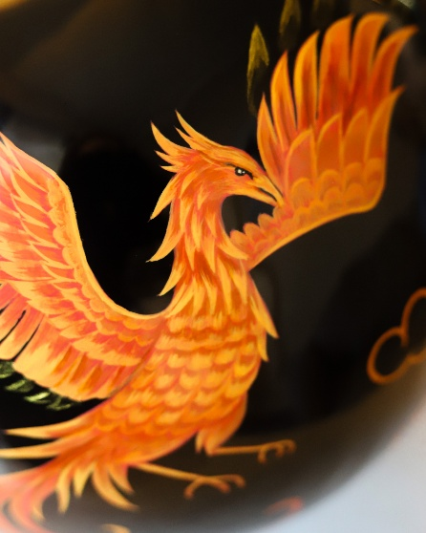 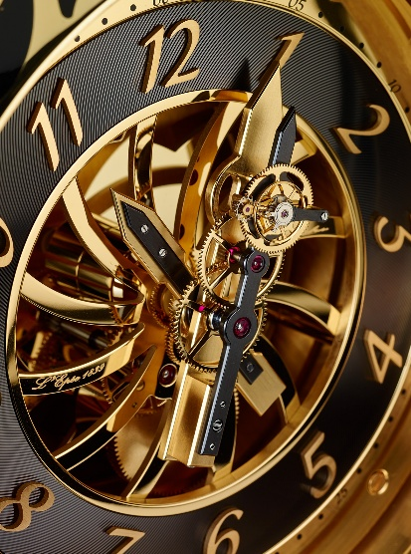

***Resident artists: Morena Fetoshi***

Inspired by the mythical phoenix—an emblem of rebirth and eternal renewal—The Phoenix Eternis Ignis reflects the cyclical dance of time itself. Like the legendary bird rising anew from its ashes, this timepiece embodies eternal beauty, harmony and time's regenerative nature.

The phrase “eternal fire” captures the myth’s essence: a continuous cycle of death and rebirth, perfectly echoing the ongoing movement of the timepiece’s mechanism. More than a clock, The Phoenix Eternis Ignis is a poetic fusion of myth and mechanical—where legend and craftsmanship ignite in a celebration of eternal time.

On a deep black background, the Phoenix emerges in vibrant shades of orange, hand-painted in fine detail as it ascends in a blaze of light. A universal symbol of rebirth and resilience, the phoenix evokes the endless cycle of time—an allegory of renewal, energy, and transformation captured within the heart of the tourbillon.

**About Artist Morena Fetoshi**

From an early age, Morena Fetoshi found in drawing an escape from everyday life — a world where imagination and creativity could take flight. What began as a childhood passion became a lifelong pursuit, leading her to specialize in watercolor and acrylic painting. Her work often focuses on animated sketches and expressive portraits, capturing both the vitality of movement and the depth of human emotion. Through her art, Morena continues to transform personal expression into vivid, timeless creations.

**Unique piece 2: The Icon – Beaux Arts**

***Resident artist : Séverine Bugna***

A celebration of life with bold vibrant colors and voluptuous forms

Round shapes sing the joy of movement, Every curve is a smile, and every pattern a heartbeat. Lines dance, contours vibrate, art becomes a celebration, a joyful tribute to life in all its explosive softness.

The *Icon - Beaux Arts* celebrates form and color through fluid, hand-painted shapes that echo the roundness of the clock itself. Its harmonious composition transforms the housing into a living canvas, where curves and hues dance in perfect balance. A joyful expression of creativity, it reflects the fusion of fine art and horological mastery.

**About Séverine Bugna**

From an early age, Séverine Bugna has lived and breathed art. After earning numerous prizes and awards, like the Drouot cotation in 2012, she transformed her passion into a vocation, presenting her work at prestigious venues such as the Grand Palais for the *Salon des Artistes Français* in 2010. Guided by the belief that art is a wellspring of joy, she also lends her talent to charitable causes. Her creativity extends beyond canvas to objects themselves, where she reimagines everyday forms as works of art—an approach that made her the perfect partner to hand-paint this extraordinary creation.

**About the movement**

At the heart of the clock lies a flying double tourbillon, mounted directly on the minute hand. The entire movement rotates around a central axis, while the escapement itself makes a full 60-second revolution. By cancelling the effects of gravity, the tourbillon stands as a pure tribute to Abraham-Louis Breguet’s original invention. With a 40-day power reserve, the result is a mechanical sculpture where time literally takes flight.

The dial features a contemporary guilloché pattern, all-black plating, and turbine-inspired curves that reveal the architecture of the movement. Three layered main plates — shaped in waves — create a sense of infinite depth, while sun-satin numerals accentuate the vortex-like motion of the dial. The flying tourbillon, designed to turn counterclockwise against the natural clockwise motion of the dial, enhances both visibility and fascination. It is a technical feat and a visual spectacle — a poetic encounter between gravity, time, and mechanical mastery.

**Technical Specifications**

Movement : In-house mechanical 40-day movement

Power reserve 40 Days

Functions : Hours, Minutes, Double Flying Tourbillon

Dimensions & Weight : Ø290 mm (40kg)

Material & Finishing : Massive Titanium Housing, Gold platted brass all black dial and bridges