**Creative project Three: The Diamond Requiem by Kostas Metaxas**

***Resident designer : Kostas Metaxas***

**Requiem** is no ordinary table clock — it is a bold horological sculpture designed in partnership with Kostas Metaxas. L’Epée 1839 unveils a dazzling new edition of Requiem, distinguished by its teeth set with brilliant-cut diamonds. This bold detail transforms the skull into an audacious jewel-clock. More than an ornament, the diamond-set teeth magnify the symbolism of Memento Mori — a reminder of life’s fragility and the fleeting nature of time, expressed here through eternal stones. With this extraordinary edition, L’Epée 1839 pushes the boundaries of mechanical art once again, blending technical mastery with a audacious artistic statement.

Shaped like a human skull, it transforms the age-old artistic theme of Memento Mori into a striking fusion of art and mechanics. Memento Mori, “Remember that you are going to die,” is both a reminder of humility and a confrontation with time itself.

At the heart of the skull lies the new **in-house**, an 8-day movement that serves as the “brain,” encapsulated yet master of its destiny. Time is revealed in the most haunting way: **hours and minutes displayed on transparent discs embedded in the eye sockets**. To read the time, one must face the skull directly — to stare into its eyes and confront mortality.

Every detail reinforces the symbolism. The protective skull allows only fleeting reflections of light to escape through its openings. Two **crossed swords** — emblem of L’Epée 1839 — pierce the temples, revealing glimpses of the oscillating escapement, like a portal into another temporal dimension.

Both graphic and technical, **Requiem** is a kinetic reminder of the intimate bond between life and time — a work of mechanical art that dares you to look death in the eye to discover… the hour.

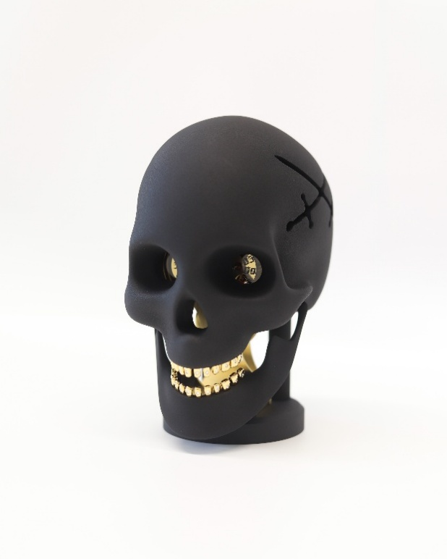 

**About Kostas Metaxas :**

“The clock is a fascinating object because you can play with what you hide and what you unveil.”

Kostas Metaxas is a magazine editor, film producer, and art-technology enthusiast whose eclectic path has shaped a bold, unconventional design vision. An Australian of Greek heritage, he draws inspiration from his travels and his passion for music, channeling them into creations that merge art, design, and innovation.

Self-taught and experimental, Metaxas explores new materials and collaborates with L’Epée 1839’s R&D team to push the limits of contemporary horology. For him, the sobriety of form mirrors the fascination of watch complications—an allegory of life’s fleeting and intricate nature.

With *Requiem*, his sculpted skull encapsulates the fragile balance between time and happiness, birth and death. Light striking the movement reveals fleeting glints of gold and silver within its shadows—a powerful reminder to *carpe diem*.

**Technical Specifications :**

Dimensions & Weight : 19 cm high x 12 cm wide x 16 cm deep, 1.9 kg

Function: Hours, minutes

Movement: L’Epée 1839 in-house movement, 8 day

Materials & finishing: Machined cast aluminum, black lacquer, or raw aluminum, and colorless protective varnish, brilliant cut diamond